* **Name of the Activity**: International Conference on Quest for Bengali Identity: A Recent Review
* **Date of the Event**:10.05.2022
* **Speaker:** 
  + - Dr. Tapodhir Bhattacharya, Ex VC, Assam University,
    - Dr. Amitava Chakraborty, Professor, Delhi University and General Secretary of International Society of Bengal Studies,
    - Dr. Soma Bhadra Roy, Associate Professor, West Bengal State University.
* **Organizing Department:** Dept. of Bengali, English Chakdaha College, and International society of Bengali Studies
* **No of Participants:** 53
* **Photograph of the Event:**

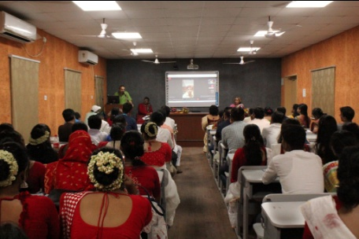

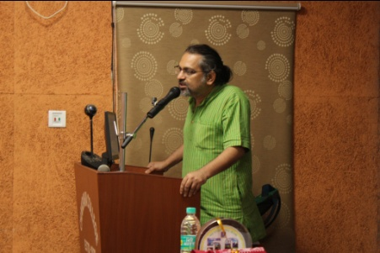

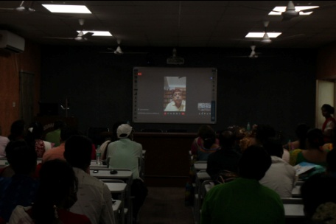

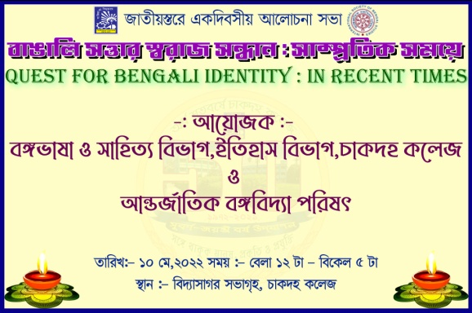

* **Attendance:**

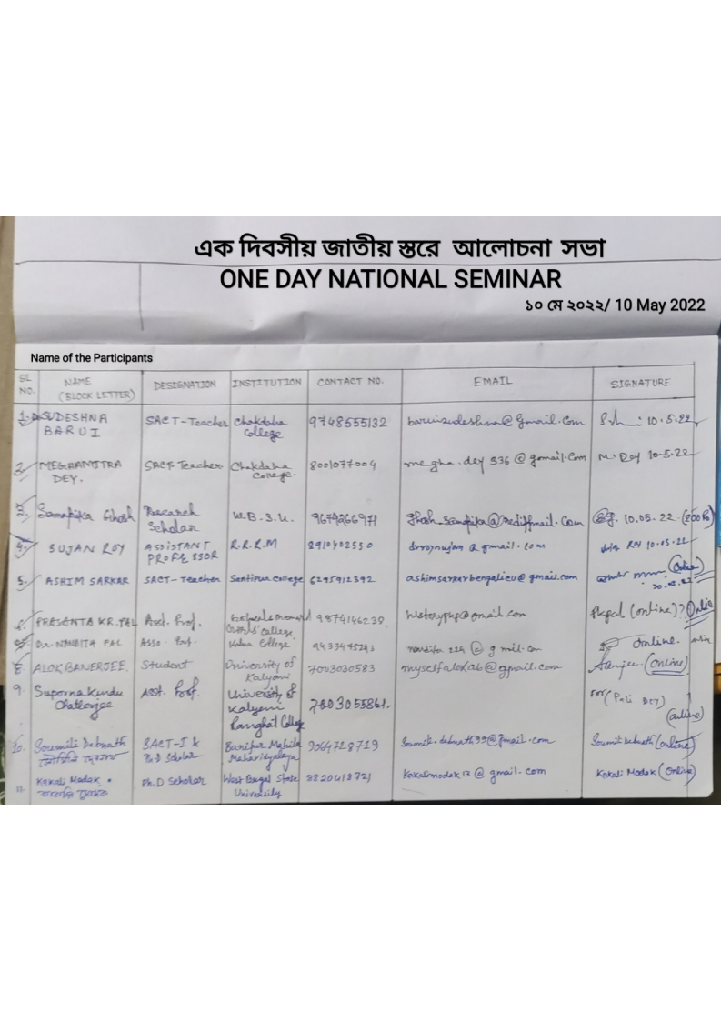

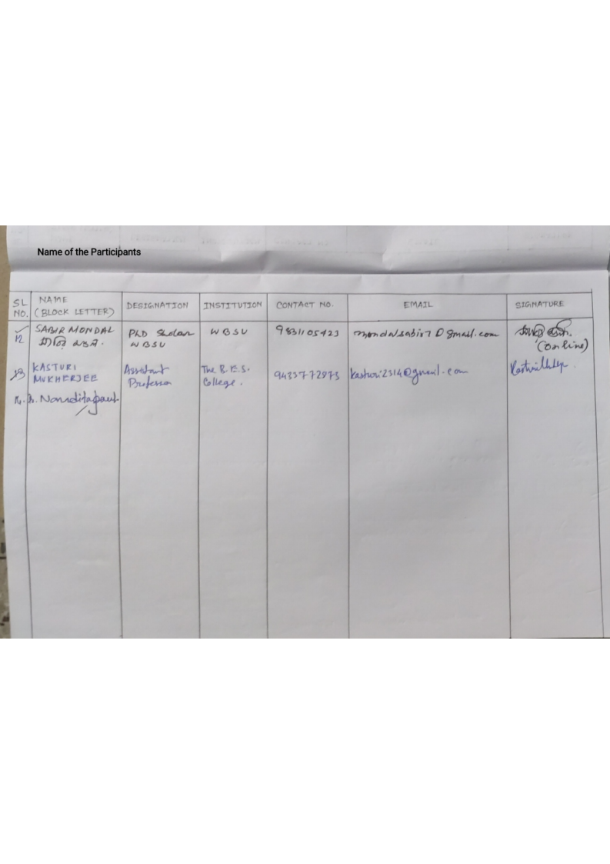

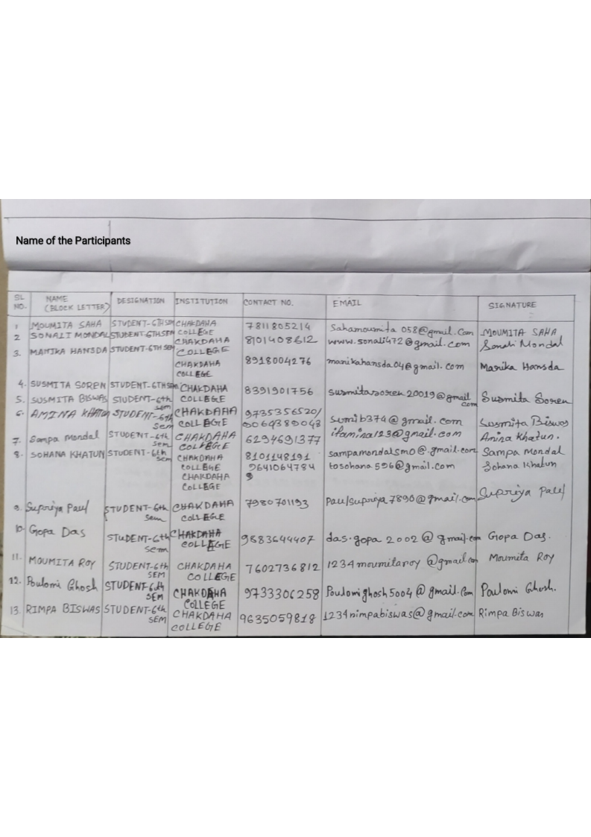

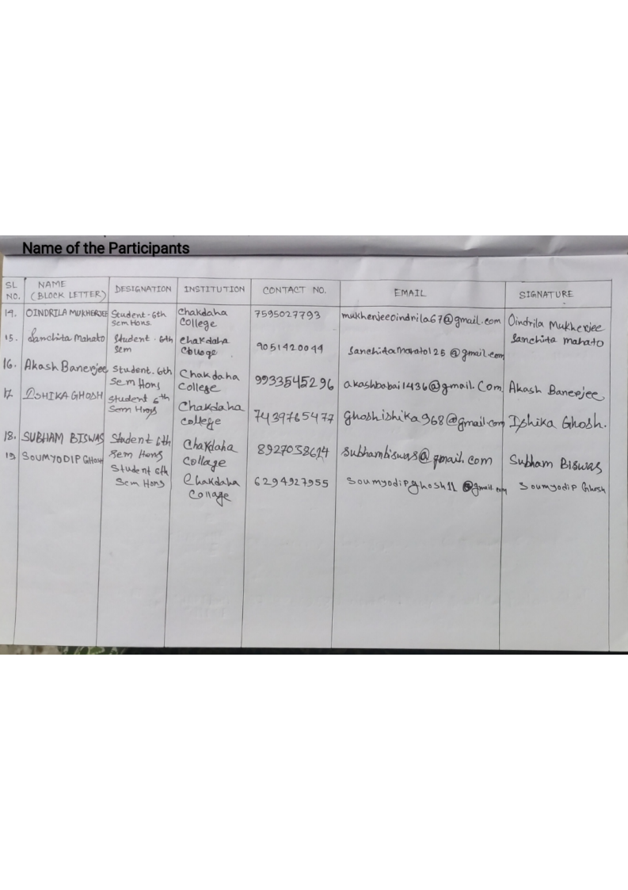

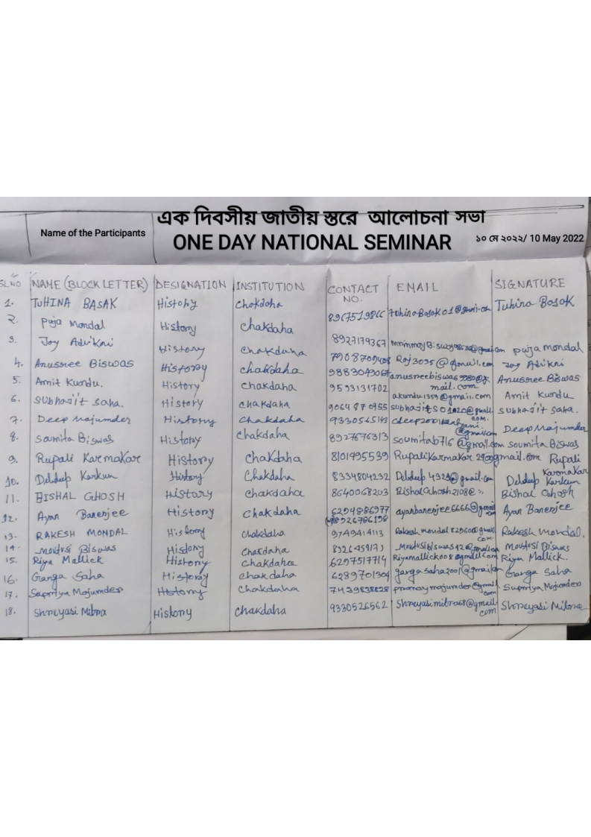

***Relevant Web Link:***

[***https://www.facebook.com/photo/?fbid=528452112348756&set=pcb.528462319014402***](https://www.facebook.com/photo/?fbid=528452112348756&set=pcb.528462319014402)